Lesson 4 Demo 2: Scheduled Builds

This section will guide you to:

* Schedule a freestyle build job in Jenkins that runs twice a day

This lab has two sub-sections, namely:

1. Creating a scheduled build in Jenkins

2. Testing a scheduled build

**Step 1:** Creating a scheduled build in Jenkins

* Create 2 empty temporary files to be used in the demo

**mkdir Trash-files**

**cd Trash-files**

**vi file1**

**vi tempo.txt**

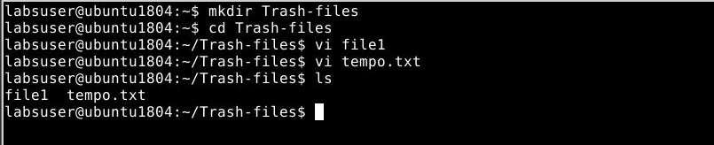

* Go to Jenkins dashboard
* Click on ***New Item***
* Select ***Freestyle project***as the build job type

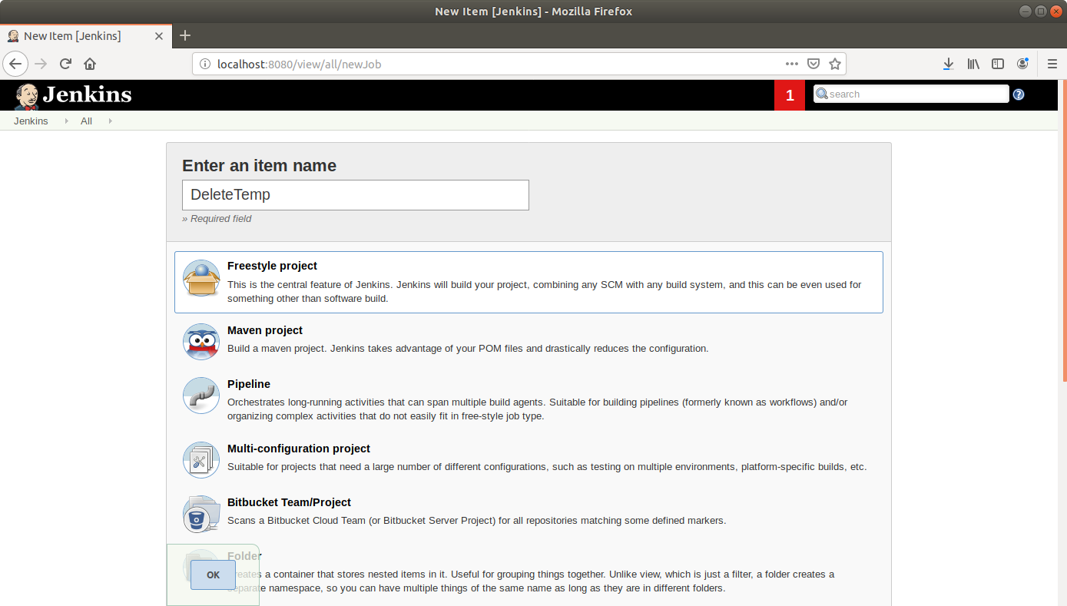

* Click **OK**
* Enter job details like description and select the **Discard old builds** option

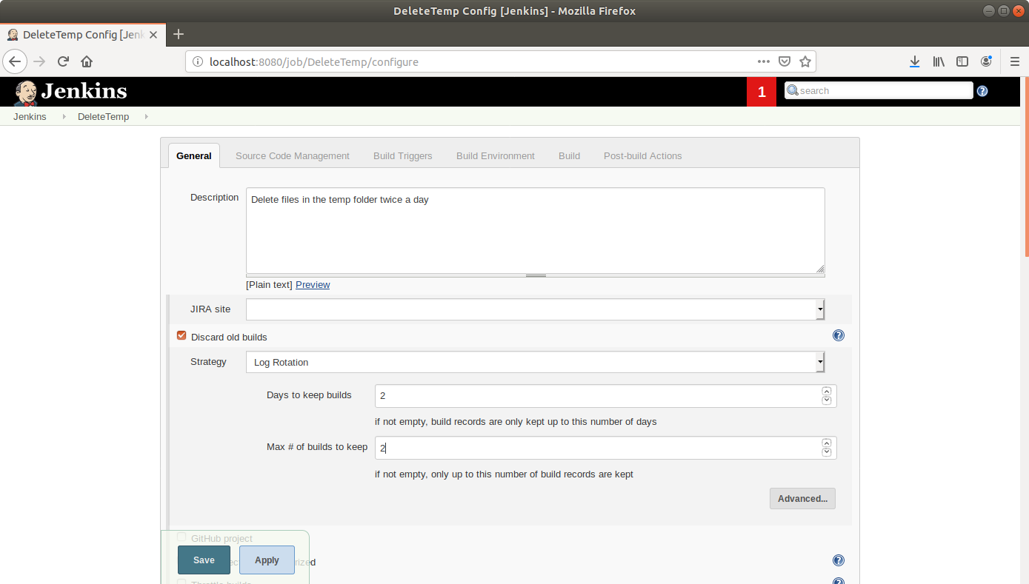

* Scroll down to the ***Build Triggers*** section and select the ***Build periodically*** option
* In the box that appears, enter the cron syntax to schedule a build every day at 11 in the morning and at night **(0 11,22 * * *)**

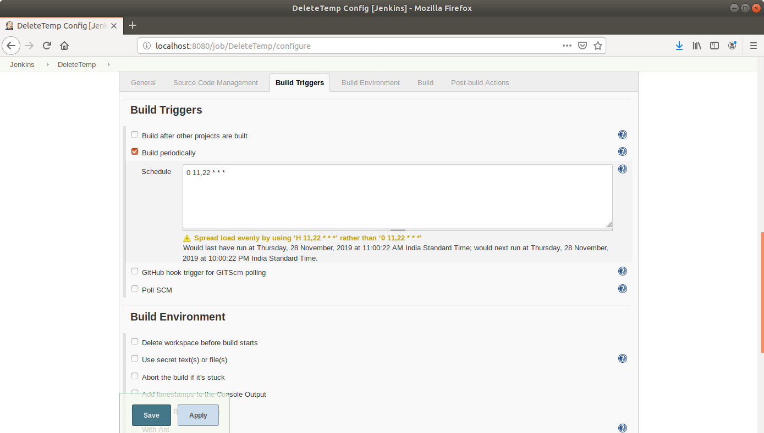

* Scroll down to the***Build*** section and click on ***Add build step***
* Select***Execute Shell***from the drop down that appears
* Enter the command to delete the files in the temp folder in the textbox that appears  
  **sudo rm -rf <path to your temporary folder>/{*,.*}**

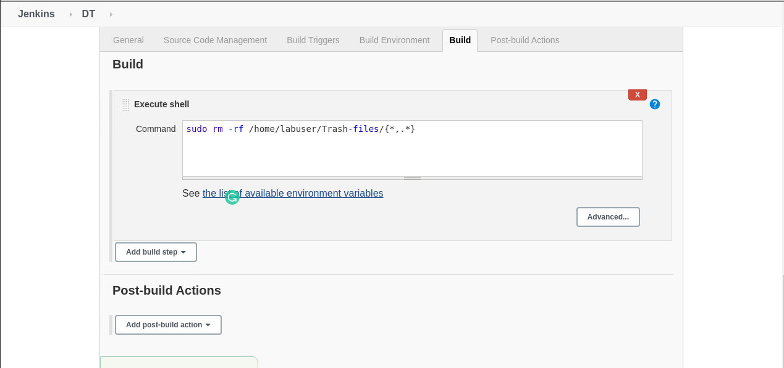

* Click **Save**

**Step 2:** Testing a scheduled build

* Click on the project name in the Jenkins dashboard
* Click ***Build Now*** in the project window to make sure the build works. Jenkins will now build your project
* Click on the ***Build History***to view the build results
* Click on the ***Console Output*** to view the build logs

